### 

**ICANN**

**Draft FY16**

**Operating Plan & Budget**

Date: 18 March 2015

Introduction 3

1 ICANN OPERATIONS 8

1.1 Resource Utilization 8

1.2 Revenues 9

1.3 Operating Expenses (Excludes Initiatives) 12

1.4 Capital Expenses 14

1.5 Initiatives 15

1.6 Risks & Opportunities 18

2 NEW gTLD PROGRAM 19

2.1 New gTLD* Financial Summary 19

2.2 New gTLD Program* Multi-year View 21

2.3 New gTLD Program* – Revenue Variance Analysis 22

2.4 New gTLD Program* – Operating Expenses Variance Analysis 23

3 TOTAL ICANN OVERVIEW 24

3.1 Resource Utilization (including Initiatives) 24

3.2 Headcount – 3-Year Overview 25

4 FY16 DRAFT Operating Plan & BUDGET – Description 26

4.1 OBJECTIVE 1: Evolve and further globalize ICANN 28

4.2 OBJECTIVE 2: Support a healthy, stable, and resilient unique identifier ecosystem 34

4.3 OBJECTIVE 3: Advance organizational, technological and operational excellence. 44

4.4 OBJECTIVE 4: Promote ICANN’s role and multistakeholder approach. 49

4.5 OBJECTIVE 5: Develop and implement a global public interest framework bounded by ICANN’s mission 55

5 APPENDIX 62

5.1 FY16 Draft Budget by project 62

5.2 Statement of Activities – Total ICANN 63

5.3 Registrar Fees 64

# Introduction

This document sets forth ICANN’s draft FY16 Operating Plan & Budget (1 July 2015 through 30 June 2016) for community feedback and input through the public comment process, which is a critical component of the accountability and transparency of the Multistakeholder model.

The Draft Operating Plan & Budget includes:

* Highlights of the ICANN Operations (excluding the New gTLD Program)
* Highlights of the New gTLD Program
* An overview of ICANN’s FY16 Budget, combining ICANN Operations and the New gTLD program.
* The detailed Operating Plan as per the management system:
* Planned portfolios of activities that support the achievement of the goals and objectives set forth in the ICANN Strategic Plan for fiscal years 2016-2020 and draft Five-Year Operating Plan, with detailed descriptions.
* Appendix with the detailed list of projects, for each portfolio, with the project-level budgeted costs by category (Appendix 1)

Note: the SO/AC additional budget requests are under review and have not been approved by the Board yet. As a result, none of these requests are included in this draft. Instead, a placeholder amount of $500,000 has been incorporated. Once the Board will have approved the requests, this placeholder will be replaced with the actual impact of the requests and incorporated in the final budget submitted for board approval.

This year’s version of the draft Operating Plan & Budget builds on the experience of the past years, thanks to community feedback and input. While last year’s version provided information on selected projects, this year’s version includes data on ALL projects to be carried out by the organization during FY16, and displays all costs categories for each project. Each project is also mapped to one of the five objectives of the ICANN Strategic Plan for fiscal years 2016-2020, through the hierarchy of portfolios and goals, making the rationale for each project and activity clear and transparent.

In addition, this year’s draft Operating Plan & Budget is offered to public comment more than seven weeks earlier than last year, while being produced in a bottom/up, detailed fashion, and including even more information (see above). This will allow more time to address the comments collected, and notably involve the Board in the response process, as per the guidance and recommendation 12 of the Accountability and Transparency Review Team 2.

More and earlier information could be produced as a result of an accelerated process that does not allow much time for adjustments along the way. We are therefore welcoming input from any reviewer on possible inconsistencies, inaccuracies or omissions, and we will continue to adjust the information contained in this document in parallel of the public comment process. Collectively, the input we receive will contribute to improve the quality of the planning and, as a result, the efficiency of the ICANN’s community in delivering its mission.

The graphic below depicts the five-year planning cycle (FY16-FY20), at a high level. The planning process consists of the ICANN Strategic Plan for fiscal years 2016-2020 and the Draft Five-Year Operating Plan, which provide input and a basis for the annual planning process.

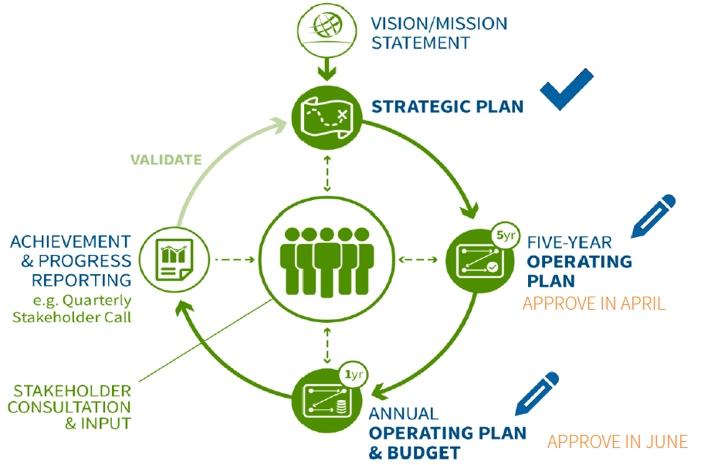

Below are the main milestones of the FY16 Operating Plan & Budget process remaining until completion:

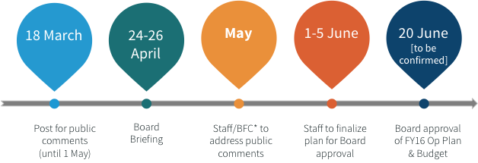

*: BFC stands for Board Finance Committee.

The structure of the budget data that follows in the rest of this document is displayed below:

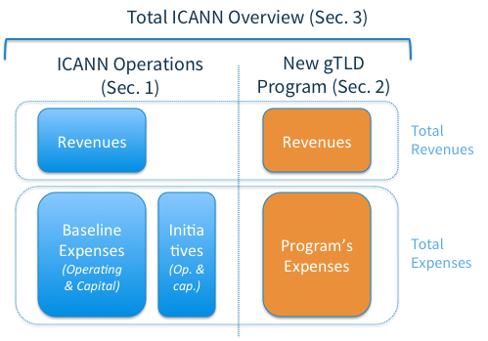

# ICANN OPERATIONS

## Macintosh HD:Users:hilary.jin:Documents:finance:graphs:ICANN Ops Resource Utilization.pngResource Utilization

## Revenues

This section provides an overview of ICANN’s revenue, starting with the assumptions that are underlying to the FY16 estimates (Tables 1 and 2). The best estimate corresponds to the retained FY16 revenue for the purpose of this draft budget submitted to public comment. The High and Low estimates provide for a sensitivity analysis of some of the revenue items.

*Table 1*

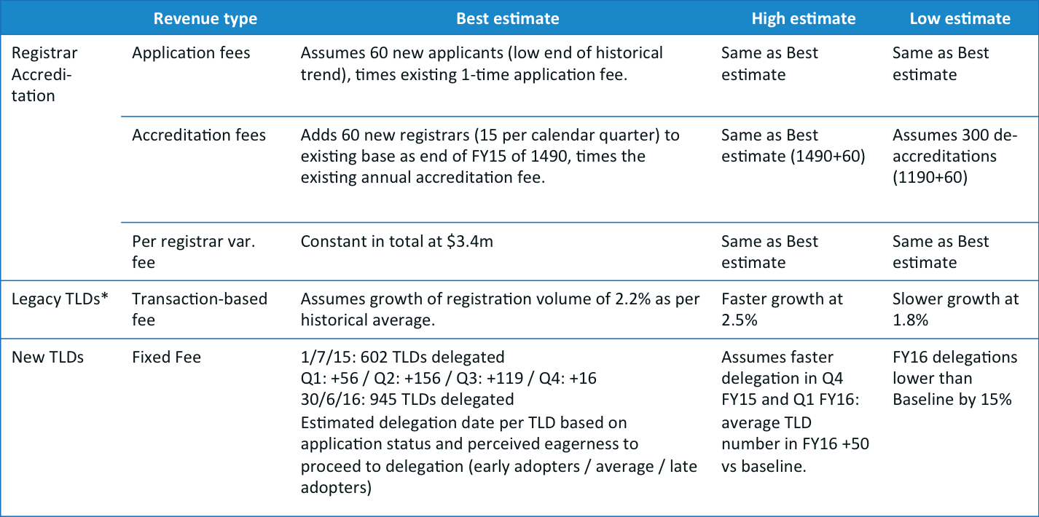

*Table 2*

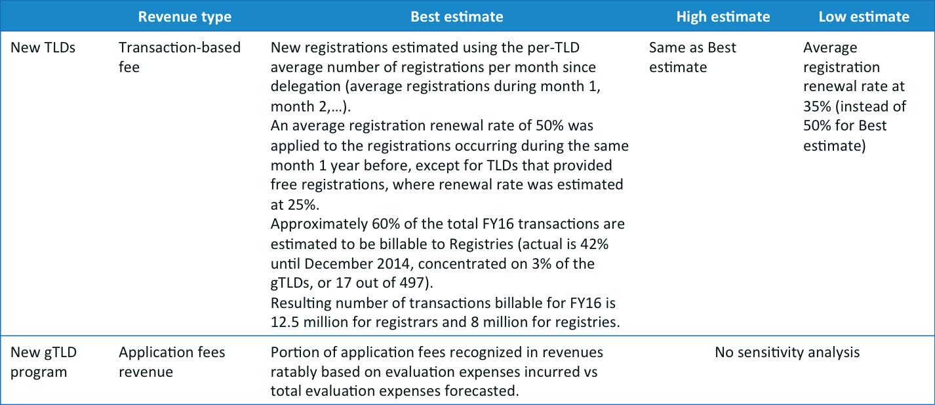

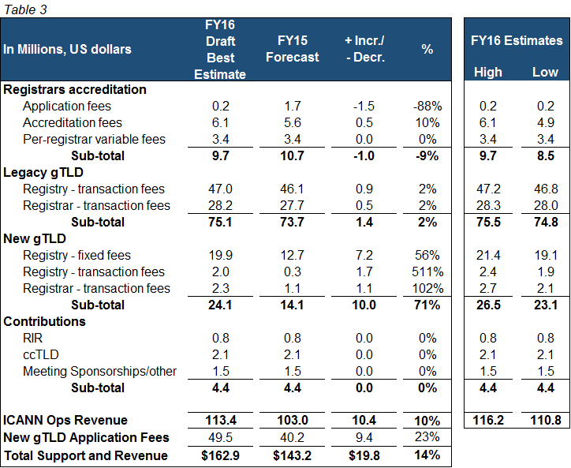The following table (Table 3) provides the revenues of ICANN by source and type, comparing for each the best estimate for the FY16 budgeted year and for the FY15 current year.

## Operating Expenses (Excludes Initiatives)



The ICANN Operations Baseline operating expenses budget (excluding Initiatives) is $113M. This represents a $10M increase from $103M in FY15.

* Non-recurring items (FY15): FY15 items not recurring in FY16 – including cost impact of the FY15 location change for ICANN 52 (from Marrakech to Singapore), legal action costs, and Public Responsibility costs are part of initiatives in FY16.
* Full year impact of FY15 Hiring: Increase in personnel costs due to 33 employees hired in FY15 working a full year in FY16 versus a partial year in FY15, plus personnel costs increases.
* FY16 Hirings: Impact of hiring 16 employees in FY16
* Priority areas: Global Domains Division (GDD) service platform ramp-up and expansion of Contractual Compliance
* Other: Limited growth in all other areas (e.g. inflationary increases)

## Capital Expenses

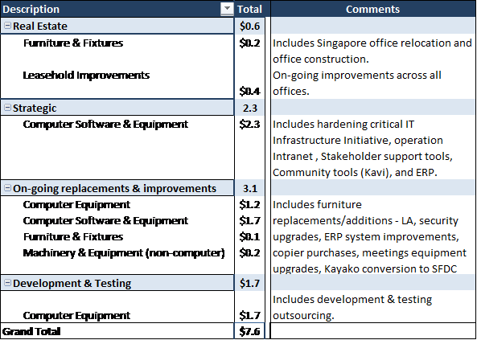

## Initiatives

Initiatives are projects relating to significant activities not in ICANN’s normal/core scope. These projects may be completed upon achievement of the intended outcome, or lead to defining future on-going activities, which will add to the scope of core operations upon obtaining community consensus. As the operating revenue of ICANN is designed to exclusively support the defined core activities of the organization, the ICANN Reserve Fund typically funds such initiatives.

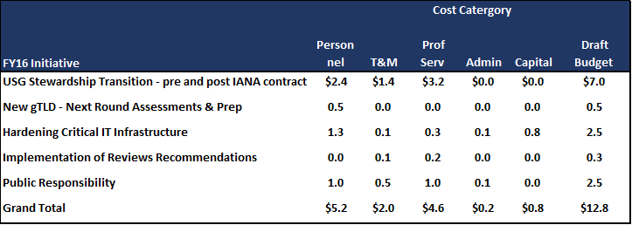

1. USG stewardship transition (pre- and post- IANA contract ):

* Covers work to occur until completion of the current 4 tracks and encompasses additionally a placeholder for the implementation of the post-USG transition stewardship and accountability mechanisms to be determined.
* Amounts estimated using the experience of the past few months, with resources estimated for 35% of personnel support, 20% of travel and meetings costs, and 45% professional services.

1. New gTLD next round assessment and preparation: Consists mainly of internal personnel time to organize the next round.
2. Hardening critical IT infrastructure:

The ICANN IT-enabled services span the entire spectrum of the ICANN Community.  IT-enabled services are a combination of software applications, the database that captures and delivers data, and the hardware on which the applications are extended to the ICANN Community.  In many cases, the Community expectation is that these services are “always available”.  In order to meet that expectation, the architecture of a range of IT-services has to be reviewed and retrofitted - in terms of software, database configuration and hardware.

1. Implementation of a recommendation from reviews:

* Policy Development Process on Registration Data Services for New gTLD, as a result of the ATRT2 recommendation.

1. Public Responsibility

* Following the Public Responsibility panel’s preliminary work, stakeholders define public interest for ICANN and design the future state of activities carried out by ICANN in the public interest. Suggested as an initiative until activities and funding are identified and allocated.

## Risks & Opportunities

*Table 9*

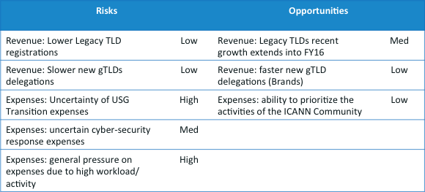

*\* Risks: defined as the possibility of a lower revenue or higher cost.*

*\* Opportunities: defined as is the possibility of higher revenue or lower cost.*

# NEW gTLD PROGRAM

## Macintosh HD:Users:hilary.jin:Documents:finance:graphs:New g 2.pngNew gTLD Financial Summary

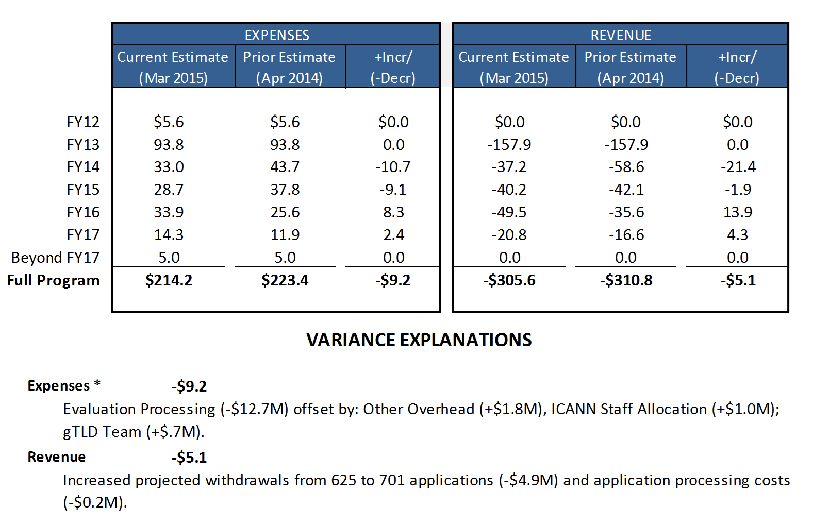

## New gTLD Program* Multi-year View



*\* All information is related to the current round of the New gTLD Program (FY12-FY17).*

## New gTLD Program* – Revenue Variance Analysis



*\* All information is related to the current round of the New gTLD Program (FY12-FY17)*

.

## New gTLD Program* – Operating Expenses Variance Analysis



*All information is related to the current round of the New gTLD Program (FY12-FY17).

# TOTAL ICANN OVERVIEW

## Macintosh HD:Users:hilary.jin:Documents:finance:graphs:Total ICANn Resource.pngResource Utilization (including Initiatives)

## Headcount – 3-Year Overview

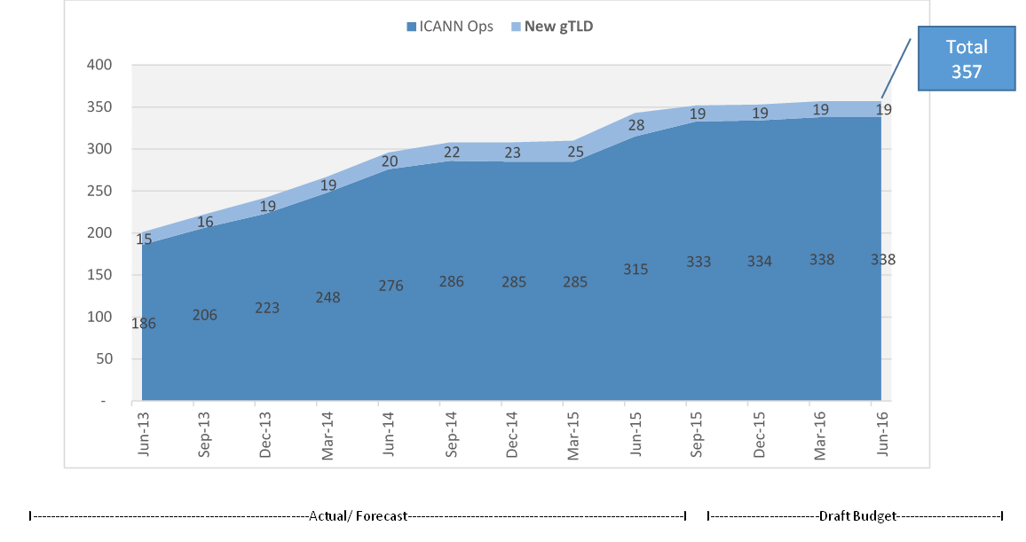

# FY16 DRAFT Operating Plan & BUDGET – Description

**Management System**

FY16 Operating Plan & Budget is informed by the Five-Year Operating Plan’s Phasing and Key Performance Indicators (KPIs) and is organized to align with the ICANN Strategic Plan for fiscal years 2016-2020 and the Five-Year Operating Plan.

This allows us to map all activities and resources back to the five main Strategic Objectives developed by a community driven bottom up process.

* **5 Objectives** – these were reviewed and revised during the development of ICANN Strategic Plan for fiscal years 2016-2020, which was adopted by the Board in October 2014.
* **16 Goals –** owned at the Global Leader (direct report to the CEO) level, the 16 goals also have defined Key Success Factors to help clarify what constitutes progress toward accomplishment of a given goal.
* **58 Portfolios** **–** within each goal is a set of Portfolios – a means of organizing ICANN’s work into groupings of projects. Portfolios also have defined Key Success Factors (KSFs) and we actively measure Key Performance Indicators (KPIs) on a regular basis
* **More than 300 Projects** – As an operational level mechanism, projects evolve continuously to reflect ongoing work. Budgeting of expenses is done at the Project level. The FY16 ICANN Operating Plan & Budget includes all projects planned for FY16, each project appearing within its related Portfolio, Goal and Objective. Each project’s associated budget can be found in the Appendix (section 5.1). Please note, the budgeted amounts in this document are inclusive of capital expenditures and initiatives.

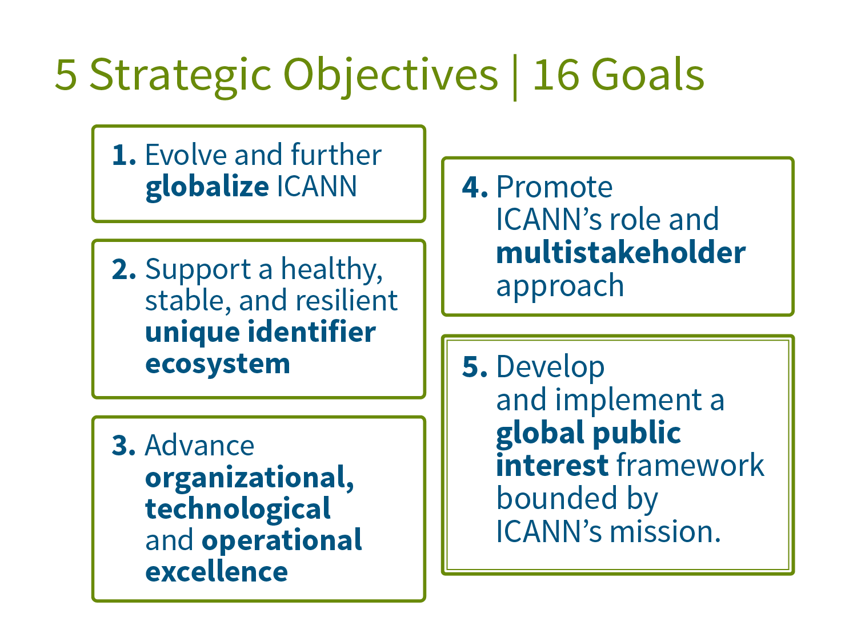 General Notes:

As the work of the organization evolves the list of portfolios also evolves and as a result portfolios may not be used anymore which could cause a break in the number sequence of portfolios.

1. OBJECTIVE 1: Evolve and further globalize ICANN

In order to meet the needs of the changing global landscape, ICANN will continue to evolve its multistakeholder processes and structures—both face-to-face and online—to enable: broad, inclusive, multilingual, engagement; new forms of participatory, consensus-based decision making; and globalized and regionalized institutional frameworks to support such enhanced functions.

* 1. GOAL: Further globalize and regionalize ICANN functions.

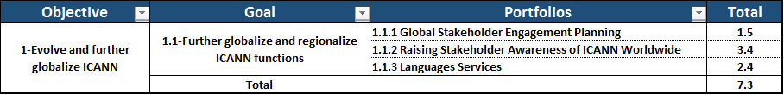

For FY16 we will focus on the following activities that work towards further globalizing and regionalizing ICANN functions:

1. Integrate global and regional communications strategies.
2. Develop comprehensive regional engagement plans and strategies covering most ICANN regions and functional community areas.
3. Further distribute ICANN functions at hub offices.

We will measure our success in achieving this goal by:

1. Creating a stakeholder engagement index. Stakeholder engagement depends on several different factors. For the index, we will first establish a baseline of current participation levels in the following programs:

* Fellowship (new/alumni/coach/mentor)
* Language Services
* ICANN language services - timeliness, effectiveness and efficiency
* Language Localization – such as the APAC Pilot Program
* Meetings Statistics (current statistics on newcomers, and by stakeholder group)
* Tracking newcomers (we will return to surveying newcomers at the end of each meeting)
* Regional participation in SO/AC groups (data provided by Policy team - GAC data provided by Government Engagement)
* Stakeholder Engagement Heat map

Creating such an index, with the metrics identified here and in 1.2 will provide a view into a wide variation of data that we are capable of collecting and in some cases already collecting. This will identify baselines to create outreach plans in the future and identify gaps in current stakeholder outreach plans.

1. Measuring the percentage of ICANN organizational functions performed across ICANN.

*Portfolios*

1.1.1 Global Stakeholder Engagement Planning

**Description:** This portfolio covers ICANN’s Global Stakeholder Engagement (GSE) prioritization and planning, across regions and functional areas.

1.1.2 Raising Stakeholder Awareness of ICANN Worldwide

**Description:** This portfolio pertains to how ICANN communicates with stakeholders around the world to help raise awareness of ICANN’s mission, its multistakeholder model and its work. Metrics to measure ongoing communications activities include active social and traditional media monitoring and measurement, global newsletter open rates and reach of speaking engagements.

1.1.3 Languages Services

**Description:** Facilitate access to ICANN and participation in its work for those who do not speak or are not fluent in English by making information accessible to those who speak other languages in order to enhance participation in, and the effectiveness of, the multistakeholder model.

* 1. GOAL: Bring ICANN to the world by creating a balanced and proactive approach to regional engagement with stakeholders.

**For FY16 we will focus on the following activities that work towards bringing ICANN to the world by creating a balanced and proactive approach to regional engagement with stakeholders:**

* Implement Global Stakeholder Engagement (GSE) web tools for supporting stakeholder engagement activities at regional and local level.
* Examine effectiveness of regional strategies launched in FY13-14.

We will measure our success in achieving this goal by:

1. Measuring the number of regional and functional engagement plans by type and status (e.g., development, implementation and maintenance).

*Portfolios*

1.2.1 Broadcast and Engage with Global Stakeholders

**Description:** Conceptualize and build a set of integrated digital tools to inform and enable engagement and collaboration with ICANN stakeholders.

1.2.2 Engage Stakeholders Regionally

**Description:** This portfolio covers the mechanisms for delivering on ICANN’s regional and functional engagement strategies (including regional and functional area work plans, stakeholder engagement heat map).

* 1. 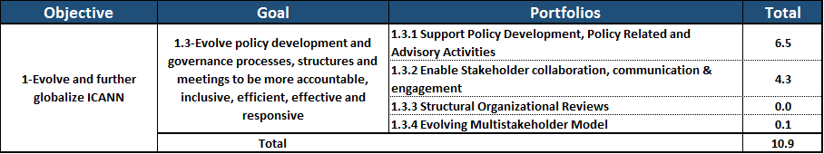GOAL: Evolve policy development and governance processes, structures and meetings to be more accountable, inclusive, efficient, effective and responsive.

**For FY16 we will focus on the following activities that work towards evolving policy development and governance processes, structures and meetings to be more accountable, inclusive, efficient, effective and responsive:**

1. To ensure that the policy development and decision-making processes are open, transparent, inclusive and legitimate, direct ongoing efforts at: (i) greater inclusion by diverse global stakeholders; (ii) additional online tools and mechanisms for participation; and (iii) evolving SO/AC structures to increase Community efficiencies and effectiveness in ICANN processes and activities

We will measure our success in achieving this goal by:

* 1. Measuring the number of participants in the policy development and governance processes by type, status and location.
  2. Creating a quality of service index (measuring factors such as “active” participants in policy development calls and meetings; # of publication subscribers/readers in "print" and on web; # of public comments submitted in ICANN Public Forums; Twitter Subscribers & Tweets; etc.)

*Portfolios*

1.3.1 Support Policy Development, Policy Related and Advisory Activities

**Description:** Optimize efficiency and effectiveness of community policy development and advice efforts.

1.3.2 Enable Stakeholder collaboration, communication & engagement

**Description:** To optimize collaboration and engagement of ICANN SOs and ACs, and increase and measure the number of exchanges (meetings and correspondence) that take place between various SOs and ACs (and the Board as appropriate) as they consult and discuss strategic and policy issues/matters.

1.3.4 Evolving Multistakeholder Model

**Description:**

* Advance planning and implementation of ICANN’s online education platform to support increased, informed, global involvement in ICANN.
* Advance planning for evolving ICANN’s multistakeholder model and facilitate the development and publication of academic research on the multi-stakeholder model for DNS coordination, Internet policy development and governance.

1. OBJECTIVE 2: Support a healthy, stable, and resilient unique identifier ecosystem

The growing and evolving unique ecosystem is operating within a changing landscape. ICANN will engage stakeholders to help support and plan for the ecosystem evolution and empower a global and responsible ecosystem that fosters growth and innovation.

* 1. 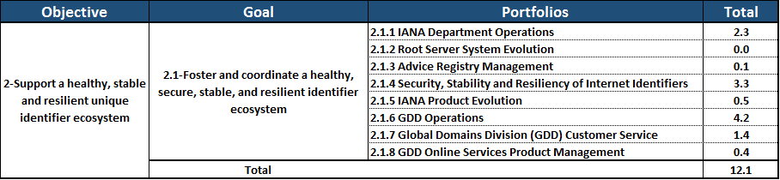GOAL: Foster and coordinate a healthy, secure, stable, and resilient identifier ecosystem.

**For FY16 we will focus on the following activities that work towards fostering and coordinating a healthy, secure, stable, and resilient identifier ecosystem:**

Develop and achieve community approval of all domain name system (DNS)/Unique Identifiers health metrics.

Develop and achieve community approval of the Stability and Resiliency Exercises specified.

Develop and achieve community approval of the designed ICANN legitimacy survey.

1. Collaborate with community to reduce gap of IPv6 and DNSSEC deployment by 5% year over year (YoY).
2. Develop and achieve community approval of the Identifier registration data access/update system requirements specified

We will measure our success in achieving this goal by:

* 1. % of GDD Service Level Targets met across multiple departments including GDD Operations, Customer Service and IANA departments.

*Portfolios*

2.1.1 IANA Department Operations

**Description**:

* Operational responsibilities for maintaining registries for protocol parameters, IP addresses, Autonomous System Numbers, and Root Zone changes.
* Maintenance of relationship with Internet Engineering Task Force (IETF), Internet Architecture Board (IAB), five Regional Internet Registries (RIRs), and TLD operators.

2.1.2 Root Server System Evolution

**Description**:

* Facilitating the continued evolution of the root server system to ensure its ongoing security, stability, and resiliency as DNS technology and operations change over time.
* Maintenance of relationships with the root server operators, Root Server System Advisory Committee (RSSAC), and related stakeholders.

2.1.3 Advice Registry Management

**Description:** Development of processes and software used to track the acceptance, implementation, and resolution of advice provided to ICANN via supporting organizations, advisory committees, review teams, and others.

2.1.4 Security, Stability and Resiliency of Internet Identifiers

**Description:** Work to observe, assess and improve the security, stability, and resiliency (SSR) of the Internet’s Identifier systems in close collaboration with other ICANN departments and the community at large. This will be achieved though a range of activities including risk awareness and preparedness, measurement and analysis of identifier system behaviors or performance, and cooperative outreach that emphasizes coordination, capability building, and knowledge transfer.

2.1.5 IANA Product Evolution

**Description:** Software enhancements, tool development, and other discrete projects to improve delivery of the IANA services.

2.1.6 Global Domains Division (GDD) Operations

**Description:** Projects related to the service implementation and ongoing delivery of services to contracted parties by the GDD**.**

2.1.7 Global Domains Division (GDD) Customer Service

**Description:** Projects related to the development, implementation and ongoing operations of the ICANN Customer Service Center.

2.1.8 GDD Online Services Product Management

**Description:** Projects for the development, support and implementation of systems for the GDD.

* 1. 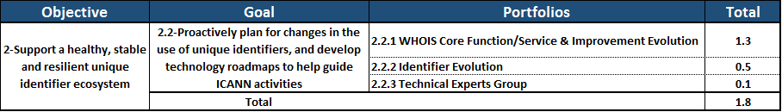GOAL: Proactively plan for changes in the use of unique identifiers and develop technology roadmaps to help guide ICANN activities.

For FY16 we will focus on the following activities that work towards proactively planning for changes in the use of unique identifiers and develop technology roadmaps to help guide ICANN activities:

1. Ensure that the IANA Department remains fully staffed.
2. Draft Technology Roadmap developed.
3. Enhance relationships with protocol/technology development organizations.
4. Base line ratio of registered domain names to active IP addresses.
5. Base line ratio of registered domain names to Internet users regionally and globally.

To demonstrate our progress in achieving this goal we will be developing a Technical Reputation Index which is intended to reflect ICANN's technical stature across the ICANN community as well as the broader internet community.

* 1. This index will include measurements of several key dimensions including:
* Engagement w/ W3C
* Number of documents published
* Number of technical sessions @ ICANN meetings
* Number of global training sessions conducted
* Number of presentations at global technical for a
* Occurrences and participation in technical sessions
* Number of leadership roles in standards organizations or program committees
* Rate of increases in perception of stature of ICANN technology team as determined via survey

*Portfolios*

2.2.1 WHOIS Core Function/ Service & Improvements

**Description:** To promote trust and confidence in the Internet for all stakeholders, ICANN is committed to enforcing its current WHOIS policy, to identify improvements to the accuracy and reliability of the WHOIS system, and to determine whether there is a better system for providing information about gTLD domain names, consistent with applicable data protection and privacy laws.

2.2.2 Identifier Evolution

**Description:** Track and support the evolution of the Internet’s system of unique identifiers through venues such as the IETF, DNS-OARC, W3C, the RIRs, and other relevant bodies.

2.2.3 Technical Experts Group

**Description:** Support and enhance the Technical Expert Group, facilitating its activities related to exploration of technical issues and opportunities facing ICANN.

* 1. 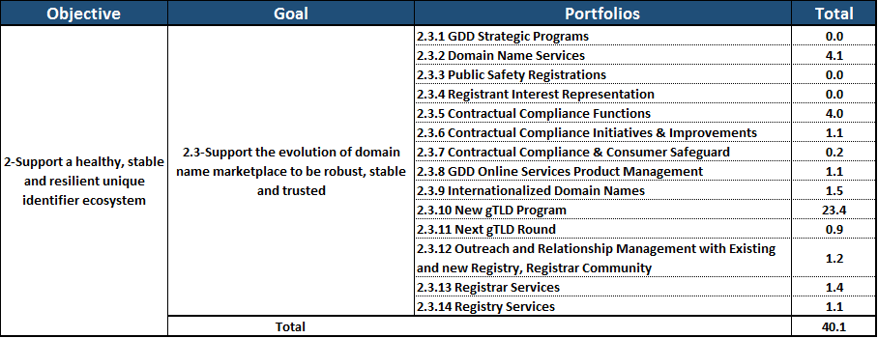GOAL: Support the evolution of domain name marketplace to be robust, stable and trusted.

For FY16 we will focus on the following activities that work towards supporting the evolution of the domain name marketplace to be robust, stable and trusted:

1. Complete Multistakeholder Satisfaction Survey baseline.
2. Define baseline of Domain Name industry segments.

We will measure progress towards achieving this goal by developing a Technical Reputation Index. This Index is intended to reflect the trust and confidence of the Internet community in the Domain Name Marketplace.

1. This index will include measurements of several key dimensions including:
2. Number net new domain registrations (legacy TLDs; ccTLDs; New gTLDs)
3. Rate of SLD renewals
4. Number of Registrants impacted by Registrar Termination vs total Registrations
5. Number Abuse incidents per MM registrations (across all TLDs)
6. % Service Level Targets (SLTs) met (including Compliance & IANA SLAs re: names)

2.3.2 Domain Name Services

**Description**: Domain Name Services ongoing operations and Industry Engagement.

2.3.5 Contractual Compliance Functions

**Description:** Day-to-day activities to ensure compliance by Registrars and Registries with their contractual obligations to ICANN and to report back to the community.

2.3.6 Contractual Compliance Initiatives & Improvements

**Description:** This portfolio comprises a series of projects focused on the continuous improvement of contractual compliance operations and systems. This includes addressing contractual compliance interpretation issues and working with the ICANN stakeholders to define relevant metrics to improve transparency and reporting of contractual compliance.

2.3.7 Contractual Compliance & Consumer Safeguard

**Description:** Projects relating to: (1) outreach to ICANN constituents regarding contractual compliance; (2) development of an analytic and nuanced approach to complex contractual compliance issues; and (3) cooperation and coordination on consumer safeguards that are beyond the scope of pure contract compliance.

2.3.8 GDD Technical Services

**Description:** Projects to enhance systems, services and technical subject matter expertise related to a safe, secure, and reliable operation of the DNS.

2.3.9 Internationalized Domain Names

**Description:** Support the introduction and universal acceptance and adoption of Internationalized Domain Names (IDNs).

2.3.10 New gTLD Program

**Description:** Projects and ongoing activities in support of the New gTLD Program.

2.3.11 Next gTLD Round

**Description:** Projects to design plan and operationally prepare for the next application round of the New gTLD Program.

2.3.12 Outreach and Relationship Management with Existing and new Registry, Registrar Community

**Description:** Create outreach and engagement strategies for registry and registrar operators to promote and cultivate a positive and constructive relationship among ICANN staff, registries, registrars and other participants in the domain name industry value chain. Activities include having dedicated account managers, conducting workshops, webinars, and inter-sessional meetings, as well as attending ICANN meetings.

2.3.13 Registrar Services

**Description:** Projects related to managing the contracts, defining new services, and building a strong relationship with current and future registrars.

2.3.14 Registry Services

**Description:** Projects related to managing the contracts, defining new services, and building a strong relationship with current and future registry operators.

1. OBJECTIVE 3: Advance organizational, technological and operational excellence.

ICANN seeks to mature our organization—to improve the skillsets, processes, and technologies through which we operate to deliver services to the ICANN community and the public. We seek to develop a greater ability to meet the speed and scale of innovation happening around us and deliver with excellence in everything we do.

* 1. 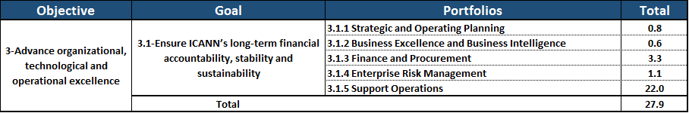 GOAL: Ensure ICANN’s long-term financial accountability, stability and sustainability

For FY16 we will focus on the following activities that work towards ICANN’s long-term financial accountability, stability and sustainability:

1. Refine the FY15 model – financial framework, roadmap, targets and metrics – with target to achieve within three years the foundation for Key Success Factors (KSFs) (outcome) supported by adequate system advancement in place.
2. Complete first internal EFQM radar evaluation & assessment of key areas of focus, identify gaps and developed mitigation/ improvement roadmap.
3. Align with budget availability and IT system implementation roadmap.
4. Review and obtain input from Board, staff and stakeholders.

We will measure our success in achieving these goals by:

1. On-time delivery index of the ICANN Planning process (includes: ICANN Strategic Plan for fiscal years 2016-2020, Five-Year Operating Plan, Annual Operating Plan & Budget, achievements and progress reporting).
2. % project completion (scope, schedule & Budget) verses plan.

*Portfolios*

3.1.1 Strategic and Operating Planning

**Description:** Review of the Five-Year Strategic and Operating Plan implementation, and the development of FY17 Operating Plan & Budget.

3.1.2 Business Excellence and Business Intelligence

**Description:** Assessment, evaluation, reporting, and guidance to advance organizational, technological and operational excellence.

3.1.3 Finance and Procurement

**Description:** All finance and procurement activities for the entire organization, in all locations. Includes the following functions: accounting (including accounts payable and billing), reporting and analysis, planning, tax, audit, procurement (PO processing, approval), sourcing.

3.1.4 Enterprise Risk Management

**Description:** Continue the focus on planning, assessing risk, evaluating mitigation, monitoring and progress reporting to minimize the effects of risks to the organization.

3.1.5 Support Operations

**Description:** Various programs and projects that support functional operations.

* 1. 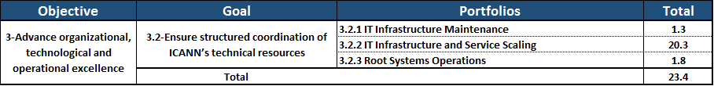GOAL: Ensure structured coordination of ICANN’s technical resources.

For FY16 we will focus on the following activities that work towards ensuring structured coordination of ICANN’s technical resources:

1. Develop and socialize a suite of uptime metrics for IT Services.
2. Define, divide and socialize IT services into a 3-tier classification.
3. Define, socialize and adopt a baseline Lean Process Capability metric for IANA functions.
4. Measure and record a baseline for the IANA functions.

We will measure our success in achieving this goal by:

1. Documenting the current infrastructure and different tiers of service reflective of the above.

*Portfolios*

3.2.1 IT Infrastructure Maintenance

**Description:** All on-going infrastructure projects and services to maintain adequate performance of the systems supporting all ICANN Operations.

3.2.2 IT Infrastructure and Service Scaling

**Description:** Work towards a top-tier global IT infrastructure performing at 99.999% uptime and have ICANN recognized by the global community as having technical excellence and thought leadership.

3.2.1 Root Systems Operations

**Description:** Facilitating the continued evolution of the root server system to ensure its ongoing security, stability, and resiliency as DNS technology and operations change over time; maintenance of relationships with the root server operators, RSSAC, and related stakeholders.

* 1. GOAL: Develop a globally diverse culture of knowledge and expertise available to ICANN’s Board, staff, and stakeholders.

For FY16 we will focus on the following activities that work towards developing a globally diverse culture of knowledge and expertise available to ICANN’s Board, staff, and stakeholders:

1. Build on the FY15 achievements related to this goal KSFs (outcome).
2. Identify benchmark organizations and derive key benchmarking metrics.

We will measure our success in achieving these goals by:

* 1. Measuring the % achievement of globally diverse culture of knowledge and expertise of staff against good-practice benchmarks and roadmaps

*Portfolios*

3.3.1 Talent Management

**Description**: Establishing and developing the right mix of skills to accomplish critical business needs at both leadership and staff level. This includes focus on areas such as talent acquisition, leadership development, team effectiveness, learning and skill development.

3.3.2 ICANN Technical University

**Description:** Providing a mechanism to improve the technical understanding of the technology ICANN coordinates.

Other related portfolios contain various projects that contribute to developing a globally diverse culture of knowledge and expertise available to ICANN’s Board, staff, and stakeholders.

1. OBJECTIVE 4: Promote ICANN’s role and multistakeholder approach.

We strive to clarify the linkages and frameworks that underlie ICANN’s responsibilities in the current Internet ecosystem. We commit to developing ways to maintain and enhance ICANN’s stewardship in an evolving ecosystem. We pledge to cultivate thought leadership on ways in which ICANN can serve a complex set of Internet constituencies. We also commit to strengthening relationships with members of this evolving ecosystem to achieve our shared goals and serve the public interest.

By extension of this effort, and without seeking to expand its role and mandate, ICANN commits to contributing to creating greater role clarity for the entire Internet governance ecosystem. We see opportunity for the ecosystem to be stronger together through greater cooperation and coordination. In this, we pledge open, transparent communications to foster a single, open, global Internet for worldwide benefit.

* 1. 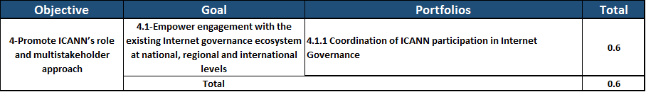GOAL: Encourage engagement with the existing Internet governance ecosystem at national, regional and international levels.

For FY16 we will focus on the following activities that work towards encouraging engagement with the existing Internet governance ecosystem at national, regional and international levels:

1. Increase % participation rates from documented baseline established in FY 2015.
2. Increase # national Internet governance multistakeholder approaches over baseline established in 2015.

We will measure our success in achieving this goal by:

1. Measuring the number of cooperation agreements or formal recognitions (such as Memorandums of Understanding (MOUs)) with international organizations with mutual recognition of roles with ICANN.

*Portfolios*

4.1.1 Coordination of ICANN Participation in Internet Governance

**Description:** This portfolio includes those projects that coordinate ICANN’s support for and participation in the Internet governance ecosystem as well as collaboration with other entities in the ecosystem on projects and initiatives of shared interest.

* 1. 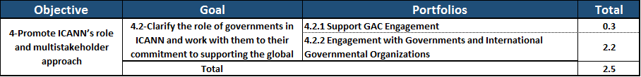GOAL: Clarify the role of governments in ICANN and work with them to strengthen their commitment to supporting the global Internet ecosystem.

For FY16 we will focus on the following activities that work towards clarifying the role of governments in ICANN and work with them to strengthen their commitment to supporting the global Internet ecosystem:

1. Increase in # of communities (government, private sector and civil society) willing to have a national multistakeholder distributed Internet Governance approach over baseline established in FY 2015.
2. Complete baseline determination to map existing entities within the Internet Governance ecosystem and their posture toward ICANN and the multistakeholder approach to Internet Governance

We will measure our success in achieving this goal by:

1. Measure the increase in the number of GAC members (level of actual active participation and level of representation at ICANN meetings).

*Portfolios*

4.2.1 Support Governmental Advisory Committee (GAC) Engagement

**Description:** This portfolio includes those projects supporting the activities of the government advisory committee and those that facilitate outreach to increase participation in the work of the GAC.

4.2.2 Engagement with Governments and International Governmental Organizations (IGOs)

**Description:** This portfolio includes those projects supporting and coordinating outreach and engagement with governments and IGOs nationally, regionally and internationally to increase governments knowledge of and participation in the global Internet Governance ecosystem.

* 1. 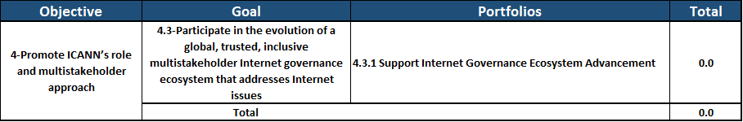GOAL: Participate in the evolution of a global, trusted, inclusive multistakeholder Internet governance ecosystem that addresses Internet issues.

For FY16 we will focus on the following activities that work towards participating in the evolution of a global, trusted, inclusive multistakeholder Internet governance ecosystem that addresses Internet issues:

1. Increase in # of partnerships and agreements with respective Internet organizations and regional and national multistakeholder Internet Governance structures over baseline established in FY 2015.

We will measure our success in achieving this goal by:

1. Measuring the number of governments and other stakeholders willing to have a national multistakeholder distributed Internet Governance structure.

*Portfolios*

4.3.1. Support Internet Governance Ecosystem Advancement

**Description:** The portfolio encompasses the collaborative work within the Internet Governance ecosystem to support evolution of multistakeholder distributed approaches.

* 1. 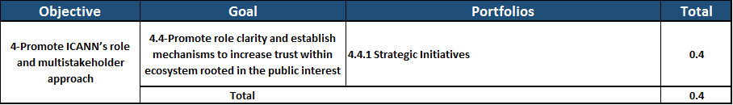GOAL: Promote role clarity and establish mechanisms to increase trust within the ecosystem rooted in the public interest.

For FY16 we will focus on the following activities that work towards promoting role clarity and establish mechanisms to increase trust within the ecosystem rooted in the public interest:

1. Assess current practices and documentation.
2. Identify and propose best practices.
3. Propose measurements and benchmarks.

We will measure our success in achieving this goal by:

1. Developing a framework that generates institutional confidence in ICANN and builds trust over time.
2. Implement “Institutional Confidence Index” as a means of measuring long-range progress.
3. Assemble and refine Accountability-related KPIs, in line with Accountability Framework proposed by One World Trust in response to recommendations of Accountability and Transparency Review Teams to implement a means of measuring ICANN’s accountability.

*Portfolios*

4.4.1 Strategic Initiatives

**Description:** Consider and formulate Institutional Confidence Index (long-range) while assembling and refining Accountability-related KPIs, in line with the Accountability Framework proposed by One World Trust (short-range). This will include establishing benchmarks and targets as well as piloting the usefulness and relevance of KPIs.

1. OBJECTIVE 5: Develop and implement a global public interest framework bounded by ICANN’s mission

ICANN seeks to develop a public interest framework for promoting the global public interest in the coordination of the Internet’s unique identifier systems and in furtherance of ICANN’s mission. The framework will clarify ICANN’s roles, objectives and milestones in promoting the public interest through capacity building, and increasing the base of internationally diverse, knowledgeable, and engaged ICANN stakeholders.

* 1. 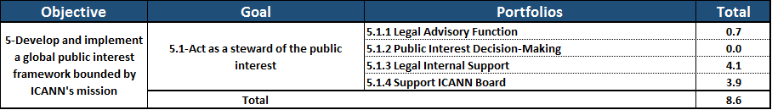GOAL: Act as a steward of the public interest.

For FY16 we will focus on the following activities that work towards acting as a steward of the public interest:

1. In order to ensure that ICANN is acting within its global public interest mandate, ICANN will seek to create framework to assist the decision-makers, policy–making bodies and advisory committees to align their work to the global public interest purpose.

We will measure our success in achieving this goal by:

* 1. Defining common consensus based definition of public interest.

*Portfolios*

5.1.1 Legal Advisory Function

**Description:** Provide legal advice to all functions at ICANN.

5.1.3 Legal Internal Support

**Description**: Provide legal support to all functions at ICANN.

5.1.4 Support ICANN Board

**Description:** Provide staff support to the ICANN Board of Directors.

* 1. 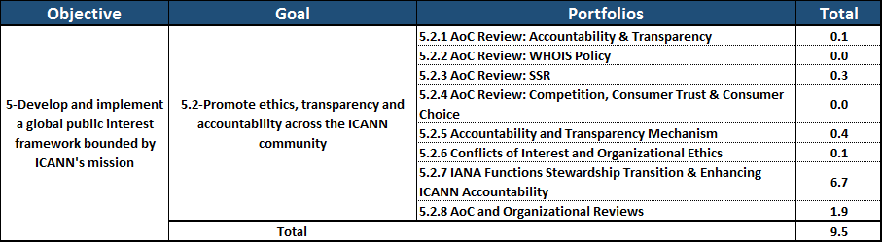GOAL: Promote ethics, transparency and accountability across the ICANN community.

For FY16 we will focus on the following activities that work towards promoting ethics, transparency and accountability across the ICANN community:

1. In order to ensure that ICANN is acting within its global public interest mandate, ICANN will seek to create and publish revised Accountability and Ethical Framework and develop baseline metrics to measure to demonstrate impact on organization.

We will measure our success in achieving this goal by:

1. Public interest framework index:

# of DIDP requests received and % of responses posted on-time.

# of Conflict of Interest Disclosure Forms completed and % of compliance.

*Portfolios*

5.2.1 AoC Review: Accountability & Transparency (see footnote 1)

**Description:** Oversee timely and effective implementation of recommendations from the Second Accountability and Transparency Review (ATRT2) and coordinate a predictable schedule of consistent implementation updates.

5.2.3 AoC Review: SSR (see footnote 1)

**Description:** Prepare for and conduct the second review under the Affirmation of Commitments regarding SSR, and complete implementation of the recommendations from the first SSR Review Team.

5.2.5 Accountability and Transparency Mechanisms

**Description:** Supporting compliance with ICANN’s Accountability and Transparency Mechanisms framework.

5.2.6 Conflicts of Interest and Organizational Ethics

**Description:** Supporting compliance with ICANN’s conflict of interest and organizational ethics policy and framework.

5.2.7 IANA Functions Stewardship Transition & Enhancing ICANN Accountability

**Description:** (1) ICANN achieves its objectives in securing the IANA stewardship transition by supporting the three operational communities (names, numbers and protocol parameters) and achieving broad community support for a proposal that satisfies the four principles in NTIA transition proposal; and (2) the CCWG-Accountability is able to produce recommendations that provide assurance that ICANN is accountable in the absence of its historical contractual relationship with the U.S. Government.

5.2.8 AoC and Organizational Reviews (see footnote [1])

**Description:** Conduct regularly scheduled reviews of ICANN entities to support their effectiveness and ongoing improvement; Support Board assessment and development of plans to maximize improvements to each entity and benefits to ICANN as a whole.

* 1. 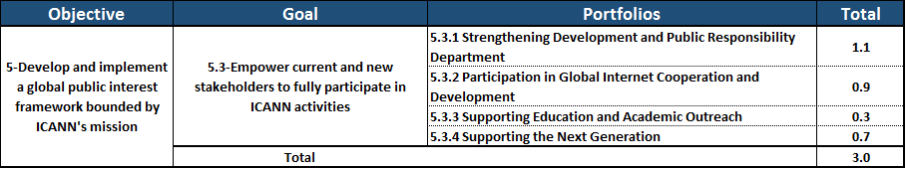GOAL: Empower current and new stakeholders to fully participate in ICANN activities.

For FY16 we will focus on the following activities that work towards empowering current and new stakeholders to fully participate in ICANN activities:

1. Create the tools to facilitate engagement and participation with focus on areas defined by regional needs through specific and measurable public responsibility programs.

We will measure our success in achieving this goal by:

* 1. Measuring the number of stakeholders participating in public responsibility programs.

*Portfolios*

5.3.1 Strengthening Development and Public Responsibility Department

**Description:** In line with the recommendations of the Strategy Panel on the Public Responsibility Framework, strengthen the DPRD and programming through specific and measurable tracks.

5.3.2 Participation in Global Internet Cooperation and Development

**Description:** In line with the recommendations of the Strategy Panel of the Public Responsibility Framework, the DPRD will continue work to streamline and formalize ICANN's approach to development and public responsibility through collaborations with regional VPs, other ICANN departments, external organizations, and through engagement with governments, ccTLD administrators, and GAC members in developing and underdeveloped countries that serve as key entry points to these regions. The purpose will be to assist in strengthening Internet Governance structures leading to enhanced relationships with SO/ACs and the wider community.

5.3.3 Supporting Education and Academic Outreach

**Description:** Supporting and broadening the global public's knowledge of ICANN and the greater Internet ecosystem by supporting educational programs, training, panel discussions, and online services including the Online Learning Platform: ICANN Learn.

5.3.4 Supporting the Next Generation

**Description:** As part of ICANN’s responsibility to increase accessibility to ICANN and the Internet governance ecosystem, this portfolio will: (1) raise awareness and encourage participation amongst the Next Generation of the community- that is to say those who are not currently not engaged or who are at the start of their relationship with ICANN and the Internet ecosystem; and (2) build on the success of the Fellowship and Newcomers programs, along with the NextGen@ICANN program by focusing on raising awareness and encouraging participation of those not currently involved in ICANN and the Internet Governance ecosystem.

# APPENDIX

## FY16 Draft Budget by project

Refer to the following documents on [ICANN.org](http://icann.org/) that include the detail of the costs by category for each project, and the full time equivalent number of allocated staff:

* FY16 Draft Budget by Project.xls
* FY16 Draft Budget by Project.pdf

## Macintosh HD:Users:hilary.jin:Documents:finance:graphs:Total ICANN SOA.pngStatement of Activities – Total ICANN

## Registrar Fees

The Registrar fees are to be approved by the Board before submission to voting by the Registrars.

Approximately 1,500 registrars are currently accredited by ICANN. This relationship is governed by the Registrar Accreditation Agreement (RAA), of which the most recent version was approved in June 2013. The two versions of the agreement currently in use were approved in 2009 and 2013. The RAA is a five year agreement that provides for the following types of fees:

* Application fees
* Annual accreditation fees
* Variable accreditation fees
* Per registrar variable fees
* Transaction based fees

In addition, since 2009, the budget has assumed an Add Grace Period (AGP) excess deletion fee to eliminate domain tasting. The amount for AGP deletion fees was assumed to be zero in past budgets and is also assumed to be zero for the FY16 budget.

Application fees are paid one time by prospective registrars at the time of application. For FY16, the application fees are estimated to be $210,000 based upon a volume of 60 applications and a per application fee of $3,500 per application.

Annual accreditation fees are fees that all registrars are required to pay annually to maintain accreditation. The fee is $4,000 per year. Registrars have the option of paying the annual $4,000 accreditation fee in quarterly installments of $1,000. For FY16, the annual accreditation fees are estimated at $6.1 million, based on an estimate of a total of 1,500 registrars renewing and being newly accredited.

Variable accreditation fees are determined based on the transaction type and volume of each registrar. There are two types of fees associated with the variable accreditation fees:

* Per registrar variable fee
* Transaction based fee

Per registrar variable fees are based on a validated concept that ICANN often expends the same quantum of effort in providing services to a registrar regardless of size. However, provided that the registrar is considerably smaller in size and in activity, some registrars will continue to be eligible for “forgiveness” of two-thirds of the standard per-registrar variable fee. To be eligible for forgiveness, the registrar must have (1) less than 350,000 gTLD names under its management and (2) no more than 200 attempted adds per successful net add in any tld. Forgiveness will be granted each quarter to all registrars that qualify.

The amount per registrar is calculated each quarter by dividing $950 thousand (one-fourth of $3.8 million) equally among all registrars that have at least been accredited for one full quarter or have made at least one transaction, taking into consideration the forgiveness factor.

In addition, a discount of 10 percent is granted to all registrars operating under the 2009 and 2013 RAA.

Transaction based fees are assessed on each annual increment of an add, renew or a transfer transaction that has survived a related add or auto-renew grace period. This fee will be billed at $0.18 per transaction for registrars operating under the 2009 or 2013 RAA (resulting from a $0.20 base fee, discounted by 10% to $0.18).

Add-grace period excess deletion fees are assessed on each domain name deleted, in excess of the threshold, during an add-grace period. The threshold is the larger of 50 or 10% of total adds, per month, per tld. The rate per excess deletion is $0.20.

Below is a summary of the estimated Registrar fees for FY16 by fee type.



End of Document

1. Based on the Affirmation of Commitments (AoC) and the ICANN Bylaws, a total of seven reviews are scheduled to take place in FY16: AoC Reviews — Competition, Consumer Choice & Consumer Trust (CCT), WHOIS Policy Review (WHOIS2), and Security, Stability and Resiliency Review (SSR2); and Organizational Reviews — At Large2, NomCom2, SSAC2, and RSSAC2. There is concern that the large number of over-lapping reviews may have significant impact on the ICANN communities’ capacity and ICANN resources. Discussions with the community, Board and staff are underway to determine the appropriate timing and schedule of these AoC and Organizational Reviews to ensure that ICANN’s accountability and transparency commitments are fulfilled and appropriately integrated into the communities’ workload and ICANN’s operations and budget. Until final decisions are reached, a total of $1.1 million has been included for these Reviews, and the draft Operating Plan includes a corresponding placeholder portfolio entitled “AoC & Organizational Reviews.” After the review schedule is established, the Reviews occurring in FY2016 will all be fully funded to ensure a quality and timely outcome. Detailed budgets will be allocated to each Review (each portfolio and project) for ongoing tracking of activities and costs.